



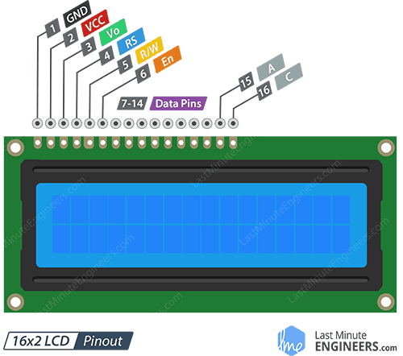
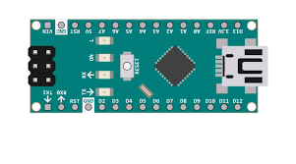



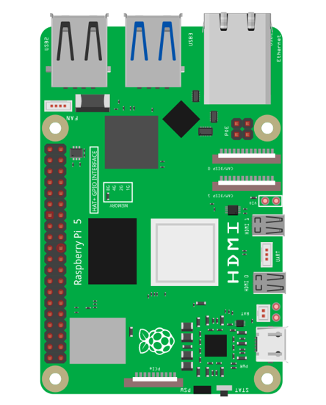





120v
24v
24v
5v
Current
Monitor
5v
Current
Monitor
5v
Pool Light
Thermometer
#6
#5
#4
#3
#2
#7
#3
#2
#1
Active
Low
Active
Low
#1
#0
#0
5v
low
high
nc
no
#7
nc
no
#6
nc
no
#5
nc
no
#4
nc
no
#3
nc
no
#2
nc
no
#1
nc
no
#0
Low
Current
Relay
Bank
5v
low
high
High
Current
Relay
Bank
nc
no
#3
nc
no
#2
nc
no
#1
nc
no
#0
240v
Valve - Jets
Valve - Returns
Pump - Main
Pump - Booster
Heater

